Background information on Species at Risk, Biodiversity and Wildlife for Forest Stewardship Planning. May 2016
This is a brief summary (not comprehensive) of some information in support of Forest Stewardship Plan development for the Thompson Rivers District.
Legal – Thompson Rivers District
Section 7 (FPPR) Notices
Species at Risk
There are no Section 7 Notices for species at risk in the Thompson Rivers District. The Kamloops LRMP was expected to cover management for species at risk. There is a background document for the Thompson Rivers District provided for information.

“This Background Information document is provided to clarify objectives set by government for species at risk as a service to planners and decision makers when preparing and approving forest stewardship plans for forestry operations in the KLRMP area. Table 1 summarizes the amount of area included in this Background Information document.”
Summary of species and the amount of area expected to be in Wildlife Habitat Areas over time from 2004 background document.
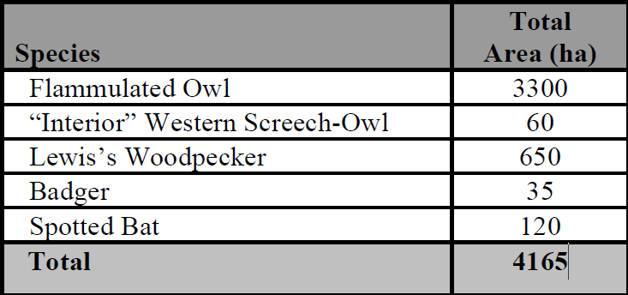

Number of WHAs in the Thompson Rivers District for the 5 species listed in the background document for the section 7 notice as of May 2016.
Species | Number of WHAs | Total Hectares
Flammulated Owl | 0 | 0
Western Screech Owl | 3 | 110
Lewis’s Woodpecker | 21 | 617
Badger | 6 | 42
Spotted Bat | 1 | 9
Total | 31 | 778

Flammulated Owl – mostly in IDFxh, south and west aspects of IDFdk. Overlaps with deer winter range. Species account, model and inventory data available. Possibility of Best Management Practices or WHAs or combination. Location data should be considered for managing home range around nest sites – 10 – 30 ha.
Western Screech Owl – majority of high value habitat on crown land has been surveyed. Presently known occurrences on crown land have a WHA designation. There could be more WHAs established in the district over time. Most of the habitat is outside of THLB or has small amounts of THLB.
Lewis’s Woodpecker – low overlap with THLB. Some inventory is being done. There may be more WHAs in the future. Perhaps best managed with BMP when operating in potential habitat. Model and occurrence data available.
Badger – low direct impacts from tree harvesting. May be indirect impacts from ground compaction, loss of dens and denning opportunity and road mortality. Perhaps best managed with BMP when operating in potential habitat. Occurrence data available and Forrex Badger Wildlife Habitat Decision Aid is available http://jem.forrex.org/index.php/jem/article/view/436.
Spotted Bat – Low direct impacts from forestry, likely low overlap with THLB. Perhaps best managed with BMP when operating in potential habitat. There may be more WHAs in the future.
Ungulate Winter Ranges
Mountain Goats
There is a section 7 notice for Goats in the Thompson Rivers District. Describes amount distribution and attributes. No THLB impact. Winter range has been mapped. Possibility of a GAR order for these.
Access a concern.
Mule Deer
See Kamloops LRMP.
New GAR order pending. ftp://ftp.geobc.gov.bc.ca/publish/Regional/Kamloops/UWR/Kamloops_TSA/mule_deer/
Access a concern
Moose
See Kamloops LRMP. See Moose and Watershed Stewardship Pilot Project. Lillooet BMP handbook. ftp://ftp.geobc.gov.bc.ca/publish/Regional/Kamloops/UWR/Lillooet_TSA/moose/
Forrex Wildlife Habitat Decision Aid. http://jem.forrex.org/index.php/jem/article/view/46/39
Possibility of GAR order?
Access a concern.
Mountain Caribou
Existing GAR order. Also the KAMLOOPS LRMP APPENDIX 10: OBJECTIVES AND CONSIDERATIONS FOR MANAGING MOUNTAIN CARIBOU DEVELOPED BY THE KAMLOOPS LRMP MOUNTAIN CARIBOU SUBCOMMITTEE provides important guidance for the modified harvest zone. Note this is different than the Appendix 10 in the Kamloops LRMP main document. See: ftp://ftp.geobc.gov.bc.ca/publish/Regional/Kamloops/Species_At_Risk/North_Thompson_Caribou/GAR_Order_Appendix10/Caribou_App10_Feb15-06.pdf
Federal Recovery Strategy has identified Critical Habitat. ‘Matrix’ habitat which is the lower elevation moose winter range is part of the Critical Habitat.
See: http://donnees.ec.gc.ca/data/species/developplans/critical-habitat-for-species-at-risk-british-columbia/?lang=en

Wildlife General
General selected information on some species groups in relation to Kamloops LRMP legal objective.
Table1: Established Objectives - Kamloops Higher Level Plan, June 2008
2.1.12 Wildlife: Ensure habitat needs of all naturally occurring wildlife species are provided for. Special attention will be paid to those red- and blue- listed species, as defined by Ministry of Environment, and species designated as regionally important (e.g. Mule Deer) Figure 3, General Resource Management Zone
Bats
See general information and guidance on bats in: Best Management Practices for Bats in British Columbia, 2016
http://a100.gov.bc.ca/pub/eirs/viewDocumentDetail.do?fromStatic=true&repository=BDP&documentId=12460
Birds
See Synthesis of Studies of Forest Bird Responses to Partial-Retention Forest Harvesting, Huggard David, Oct 2006 and Stand-Level Retention and Forest Birds, A Synthesis of Studies. Centre for applied conservation research, UBC

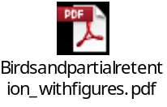

Also new release on the state of birds in North America. See: http://www.stateofthebirds.org/2016/

Raptor and their nests
See Guidelines for Raptor Conservation During Urban and Land Development in BC.
http://www.env.gov.bc.ca/wld/documents/bmp/raptor_conservation_guidelines_2013.pdf
Goshawks – some evidence of potential population declines in some parts of BC.
See A Scientific Basis for Managing Northern Goshawk Breeding Areas in the Interior of British Columbia: Best Management Practices
http://www.forrex.org/sites/default/files/forrex_series/176-goshawk-final.pdf
and the associated Brochure Best Management Practices for Northern Goshawk Breeding Areas in the Interior of British Columbia
http://highcountryconsulting.ca/pdf/Goshawk%20Brochure%20March%202011.pdf
Furbearers
Fisher
See Fisher Habitat and Forest Management Web Module
http://www.fisher.forrex.org/
Forrex Wildlife Habitat Decision Aid. http://jem.forrex.org/index.php/jem/issue/view/1
Pine Marten
See BEC zone capability mapping for range and distribution of marten in the region. ftp://ftp.geobc.gov.bc.ca/publish/Regional/Kamloops/
Rattlesnakes
Small area of overlap with foraging areas and THLB. Mapping and BMP being developed.
Forest Planning and Practices Regulation
Stand and Landscape Level Biodiversity
Objectives set by government for wildlife and biodiversity — landscape level
9 The objective set by government for wildlife and biodiversity at the landscape level is, without unduly reducing the supply of timber from British Columbia's forests and to the extent practicable, to design areas on which timber harvesting is to be carried out that resemble, both spatially and temporally, the patterns of natural disturbance that occur within the landscape.
This is an important part of forest biodiversity - managing for a seral stage distribution at an appropriate scale will address forest biodiversity concerns at the broad level
Objectives set by government for wildlife and biodiversity — stand level
9.1 The objective set by government for wildlife and biodiversity at the stand level is, without unduly reducing the supply of timber from British Columbia's forests, to retain wildlife trees.
Maintaining effective forest structure and recruitment for forest structure and locating stand retention areas in association with features such as terrain features (eg ridges, rocky outcrops, gullies), wetlands or wetter sites, etc can reduce impacts at a stand level and ultimately at the larger landscape level. See MRVA report. See Synthesis of Studies of Forest Bird Responses to Partial-Retention Forest Harvesting, above.
Water and Watershed Management
See expectation letter, MRVA, Culmulative Effects Information, Watershed Hydrologic Risk Assessments and Research information.
Access and Access Management
Roads and vehicle access is an issue for numerous species. Initial list of species that could be focus of access management: Moose, Mountain Goats, Grizzly Bears, Bull Trout systems.

